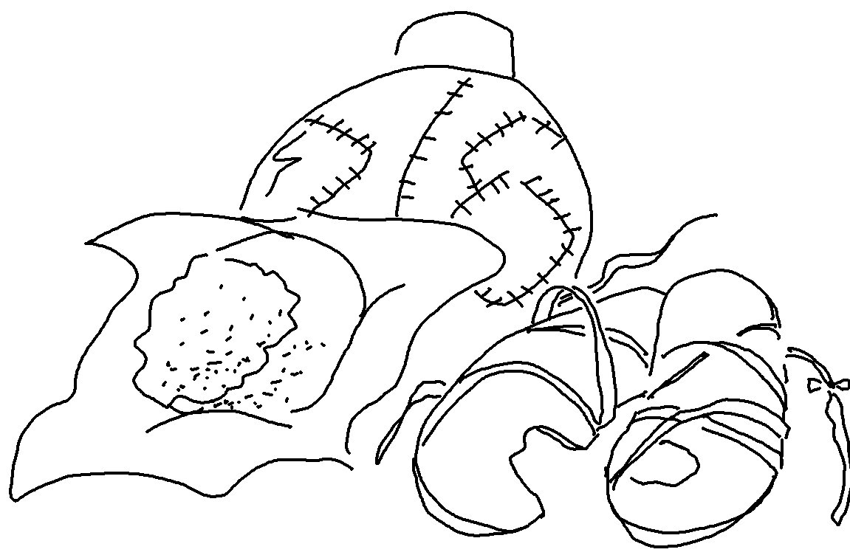
The Lord detests _ _ _ _ _ lips, but He _ _ _ _ _ _ _ _ in those who tell the _ _ _ _ _.
Proverbs 12:22_{NLT}

